Adrien Protzel

Kaggle: Apples

1. MLE(w) = $\sum_{i=1}^{N}{}|y_{i}-w^{T}x_{i}|$

Likelihood = $\prod_{i=1}^{N}{}\frac{1}{2b}e^{-\frac{{|y}_{i}-w^{T}x_{i}|}{b}}=log(\frac{1}{2b^{n}}e^{-\frac{1}{b}})\sum_{i=1}^{N}{}|y_{i}-w^{T}x_{i}|$

argmax = $-\sum_{i=1}^{N}{}|y_{i}-w^{T}x_{i}|$, argmin = $\sum_{i=1}^{N}{}|y_{i}-w^{T}x_{i}|$



| y | 0 | 0 | 0 | 1 | 0 | 0 | 1 | 0 | 0 | 1 | 1 | 0 | 1 | 1 | 1 | 1 |
| --- | --- | --- | --- | --- | --- | --- | --- | --- | --- | --- | --- | --- | --- | --- | --- | --- |
| P(y|x) | 0.1 | 0.1 | 0.25 | 0.25 | 0.3 | 0.33 | 0.4 | 0.52 | 0.55 | 0.7 | 0.8 | 0.85 | 0.9 | 0.9 | 0.95 | 1.0 |

| t=0 | 1 | 1 | 1 | 1 | 1 | 1 | 1 | 1 | 1 | 1 | 1 | 1 | 1 | 1 | 1 | 1 |
| --- | --- | --- | --- | --- | --- | --- | --- | --- | --- | --- | --- | --- | --- | --- | --- | --- |
| t=0.2 | 0 | 0 | 1 | 1 | 1 | 1 | 1 | 1 | 1 | 1 | 1 | 1 | 1 | 1 | 1 | 1 |
| t=0.4 | 0 | 0 | 0 | 0 | 0 | 0 | 0 | 1 | 1 | 1 | 1 | 1 | 1 | 1 | 1 | 1 |
| t=0.6 | 0 | 0 | 0 | 0 | 0 | 0 | 0 | 0 | 0 | 1 | 1 | 1 | 1 | 1 | 1 | 1 |
| t=0.8 | 0 | 0 | 0 | 0 | 0 | 0 | 0 | 0 | 0 | 0 | 0 | 1 | 1 | 1 | 1 | 1 |
| t=1 | 0 | 0 | 0 | 0 | 0 | 0 | 0 | 0 | 0 | 0 | 0 | 0 | 0 | 0 | 0 | 0 |

recall= $\frac{TP}{TP+FN}$, precision= $\frac{TP}{TP+FP}$

|  | TP | FP | TN | FN | Recall | Precision |
| --- | --- | --- | --- | --- | --- | --- |
| t=0 | 8 | 8 | 0 | 0 | 1 | 1/2 |
| t=0.2 | 8 | 6 | 2 | 0 | 1 | 8/14 |
| t=0.4 | 6 | 3 | 5 | 2 | 6/8 | 6/9 |
| t=0.6 | 6 | 1 | 7 | 2 | 6/8 | 6/7 |
| t=0.8 | 4 | 1 | 7 | 4 | 1/2 | 4/5 |
| t=1 | 0 | 0 | 8 | 8 | 0 | 0 |

1. -
2. -
3. Increase of about 10% accuracy. Yes very meaningful difference
   1. No Bias: [-0.2464, 0.8677, 0.2008, 0.2785, -0.6761, -0.3325, 0.4337, -0.3499]
   2. Train accuracy: 86.27%
   3. Bias: [-3.4144, 0.08, 0.4192, 0.2177, 0.2745, -0.2522, 0.0561, 0.2724, -0.0528]
   4. 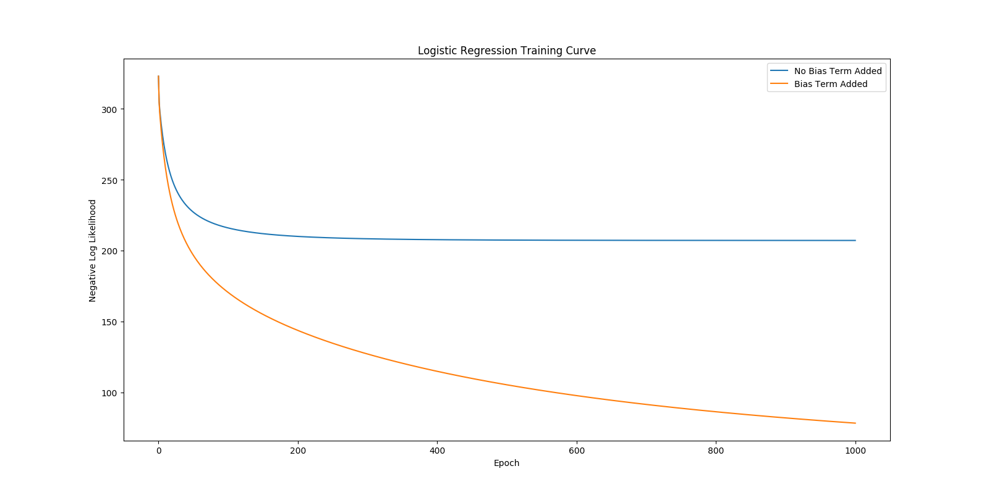Train accuracy: 96.35%

Blue=No Bias

Orange=Bias

The non-bias plateaued while

the bias continues to 0.

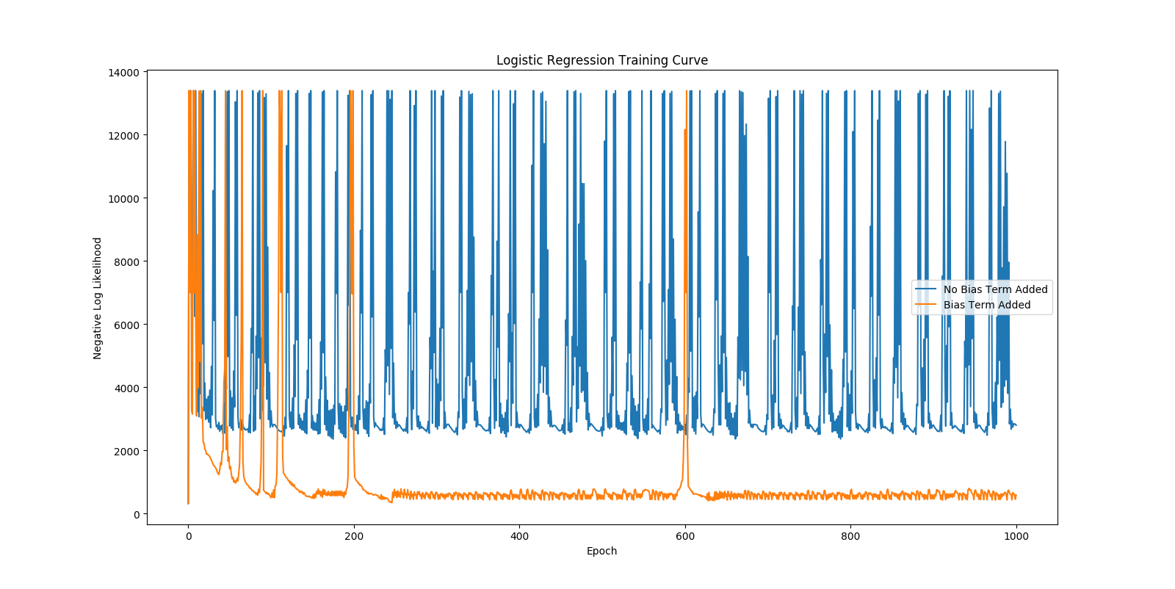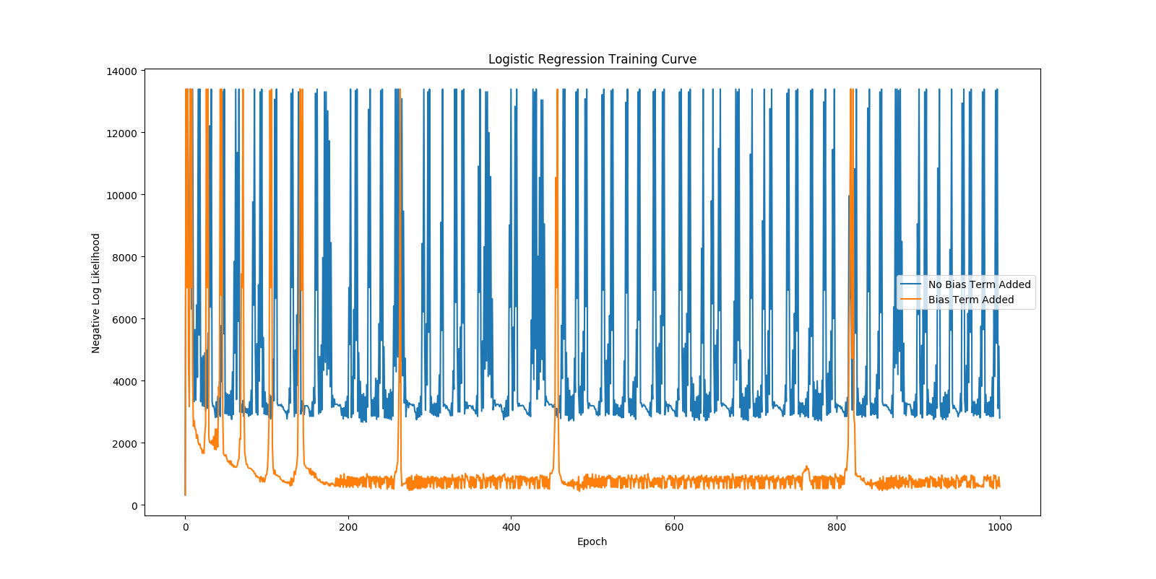

Step = No bias acc | bias acc

1.0 = 86.27% | 96.78%

0.1 = 84.12% | 96.28%

0.01 = 72.96% | 97.00%

0.001 = 86.70% | 97.00%

0.0001 = 86.27% | 96.35%

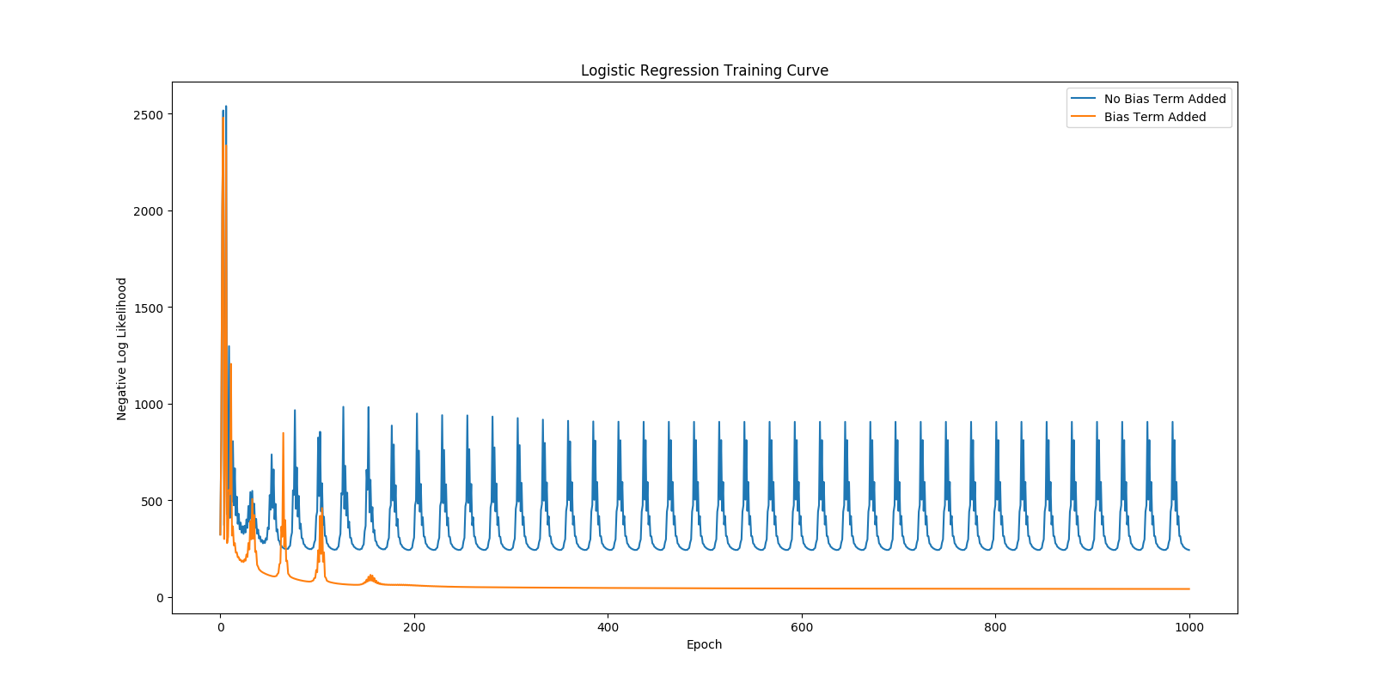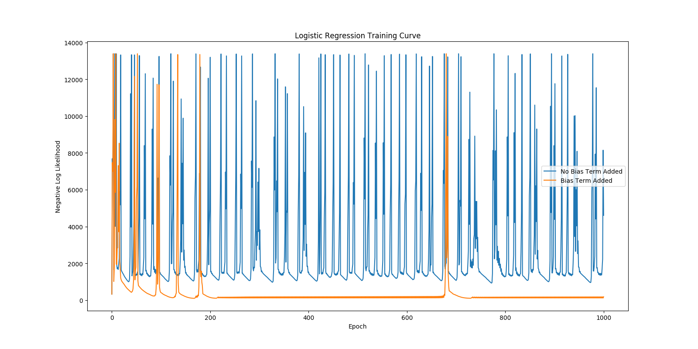0.00001 = 85.62% | 90.77%

Both lines jump around but the no-bias is very significant with a higher number of steps. Eventually, the lines will smoothen out, but the bias line never plateaus or converges.

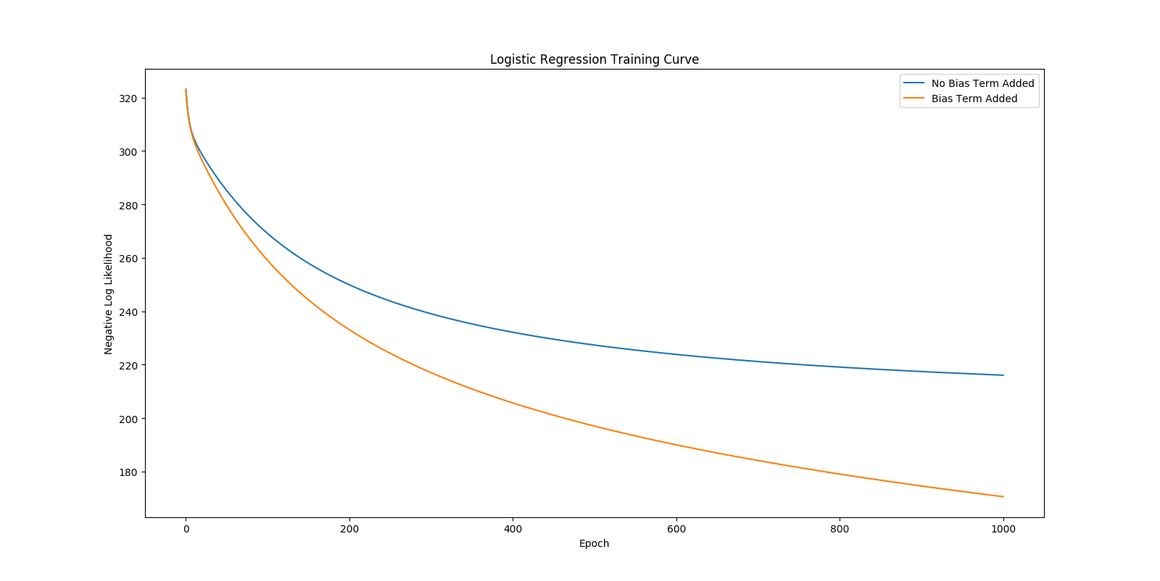

1. 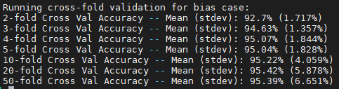

The mean accuracy increased as the number of folds increased. My score is 92% which makes it a little low compared to the 95% on 50 folds but in line with the 2 folds. The accuracy did seem to begin to dip down after 20 folds.

1. 20 hours
2. Moderate
3. Help for math bits
4. 80%